Spring Cloud

* Overview
* Externalized Configuration
* Microservices
* Service Discovery
* Discovery Client
* Security
* Load Balancing
* Circuit Breaker: Resilience4j
* Zuul

Spring Cloud:

It helps in providing the tools to quickly build the distributed applications with common design patterns like:-

Service Discovery  
Discovery Client  
Circuit Breaker  
Load Balacing

Using this coordination between the distributed applications can be simplified.

With spring cloud you can simplify the development of distributed applications with simple annotations & configurations.

Spring Cloud uses the Spring Boot project to quickly develop the applications, we must use the compatible spring boot projects to work spring cloud.

Spring cloud uses many spring boot features:

* Starter Projects
* Compatible version of Spring Boot for Spring Cloud
* Creating an executable jar/war
* Property configuration
* Passing the configurations from command line at runtime
* Deploying the war on external server
* Actuators endpoints: health, metrics, beans
* MVC implementation: Service, DAO
* JPA Repository
* REST based services
* Curl commands
* Working on GIT

In spring cloud we are going to deal with:

* Externalized Configuration: This makes a configuration which is remotely available for multiple applications, you can apply security like Encryption by using JCE (Java Cryptographic Extension), You can also force applications to pass the credentials while accessing the remote location
* Microservices: Service Discovery, Discovery Client, Load-Balancing, we need to know some design patterns, like Development patterns, resilience pattern, routing pattern.
* Circuit Breaker: Hystrix (Deprecated), Resilience4j
* Zuul: Common door for all the incoming request to your service discovery, dynamic routing
* Secuirty

Getting Started

1. New Spring Boot project
2. Add spring cloud version to the existing project

Spring Boot compatible release train for spring cloud

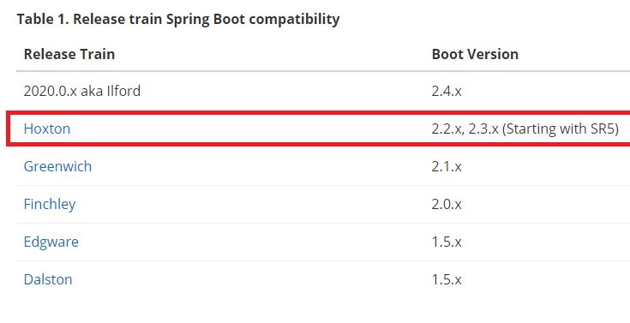

Spring Boot essentials:

Starting from creating project to Creating rest services with JPA (in-memory database h2)

Spring Boot with Maven without spring initializr

pom.xml

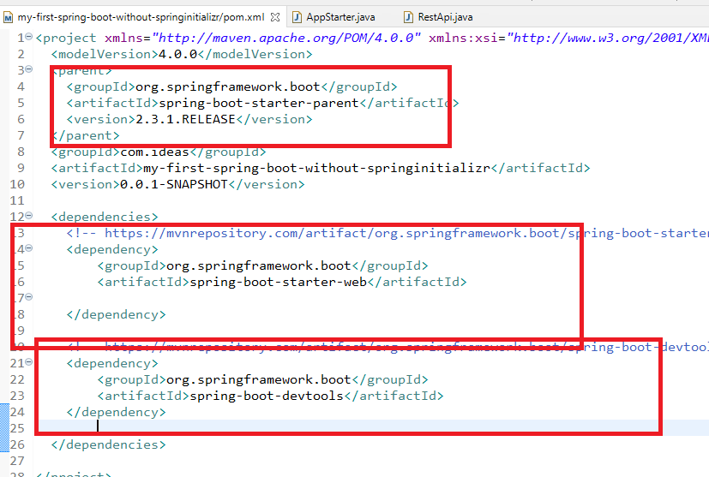

AppStarter

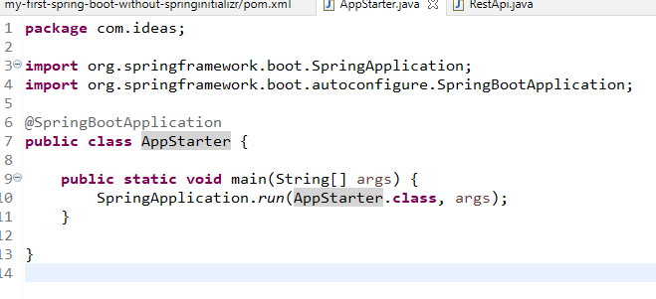

RestApi

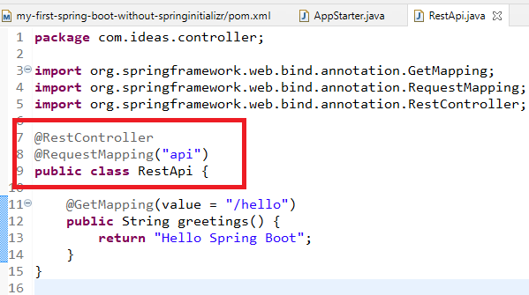

Output:

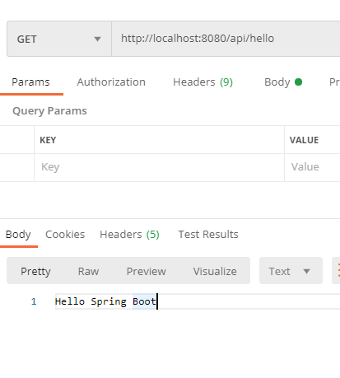

Through cURL you can pass the GET request

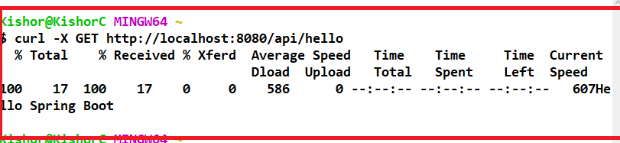

Some of the useful curl commands:

POST request with JSON data:   
curl -X POST url -H “Content-Type:application/json” -d “{...}”

PUT request:  
curl -X PUT url

Spring boot project with Spring Initializr

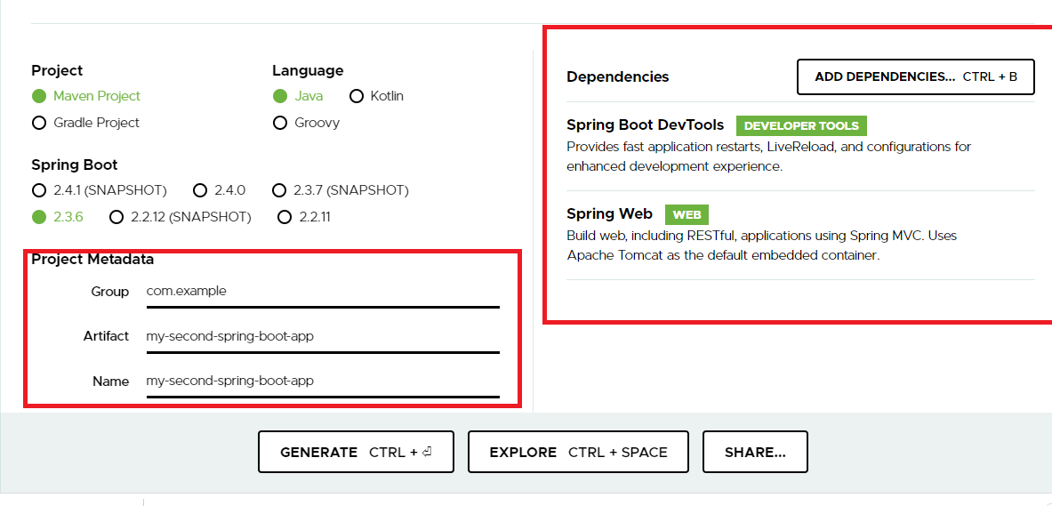

RestApi

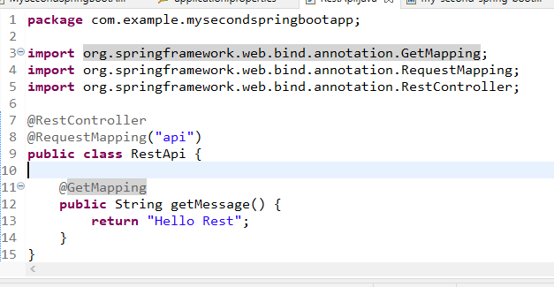

Benefits

* You will get UI based dependency configuration
* You will get pre-defined code to run/launch spring application
* You will get a plugin to create executable Jar/War
* You will get application.properties
* You will get compatible version of spring boot

How to create an executable jar file

You should use *mvn package* command



You will get a jar file inside target folder

How to execute the jar file

You should use *java -jar <<file.jar>>*

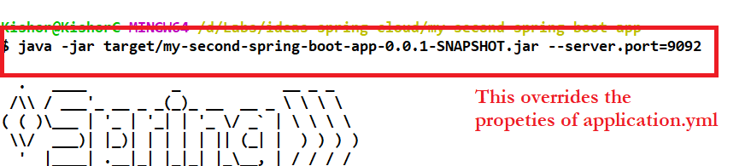

Deploying the war in an external server

* You need to perform some changes
* Main method doesn’t work hence you must use a filter called SpringBootServletInitializer which has a configure() method
* Once any class extends SpringBootServletInitializer configure() method will be executed you can write the launching of spring boot application inside the configure
* You must create WAR file instead of JAR file

Steps:

* Change the packaging in pom.xml to war
* Embedded server must not be considered when war is built, you must use <scope>provided in pom.xml
* You must create a class that extends SpringBootServletInitializer

pom.xml

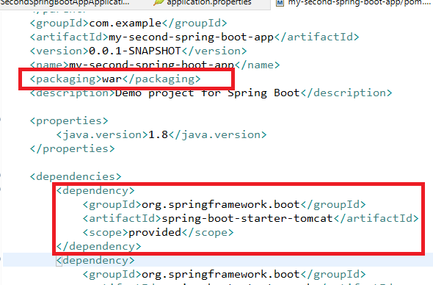

ServletInitializer

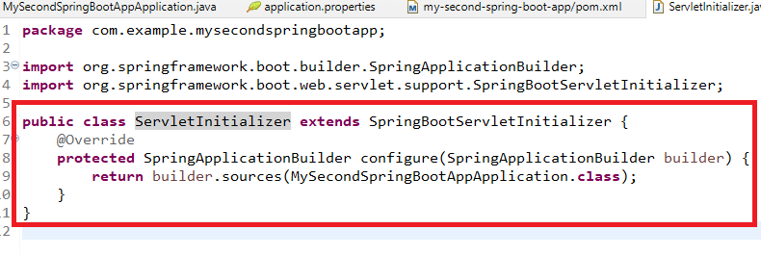

Now you can use mvn package

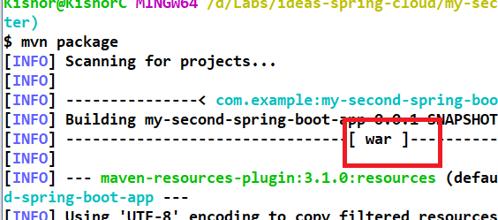

How to load the existing XML configuration in spring boot

You must use @Configuration class with @ImportResource annotation

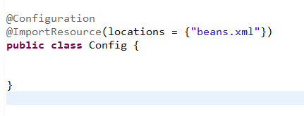

Spring Boot best practices

1. Build systems - Maven, Gradle
2. Structuring your code - keep @SpringBootApplication in the root package
3. Avoid default package
4. Try to use @Configuration class instead of XML files
5. Don’t enable devtools in the production
6. Refer the migration guides when you want to migrate from old version to new version

Spring Actuator

You can monitor and manage applications in the production

you can see beans, health, metrics

health:

beans:

env:

metrics:

Spring Boot Starter JPA

You can use JpaRepository and CrudRepository which has inbuilt implementation as per the generics of your entity.

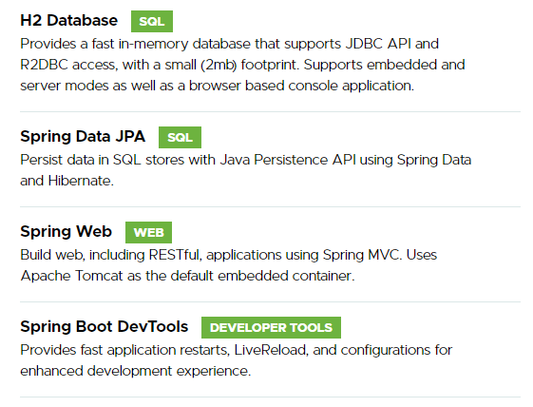

JpaRepository gives you lot of methods like

save() : it is used store & update both

deleteById():

findById()

findAll()

application.properties

spring.datasource.driver-class-name=org.h2.Driver

spring.datasource.url=jdbc:h2:mem:myDB

spring.datasource.username=username

spring.datasource.password=password

Profile.java

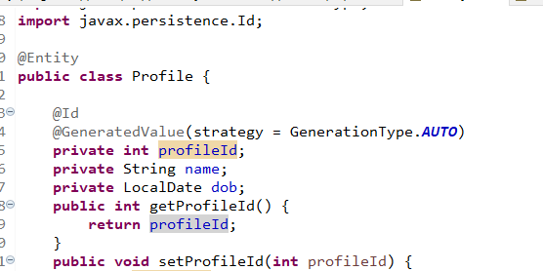

ProfileDaoRepository.java

**package** com.example.myspringbootappdatajpa;

**import** org.springframework.data.jpa.repository.JpaRepository;

**public** **interface** ProfileDaoRepository **extends** JpaRepository<Profile, Integer> {

}

Service class

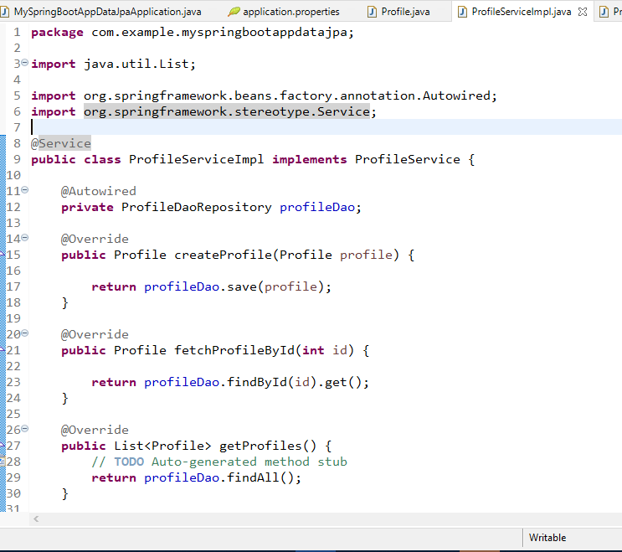

Rest

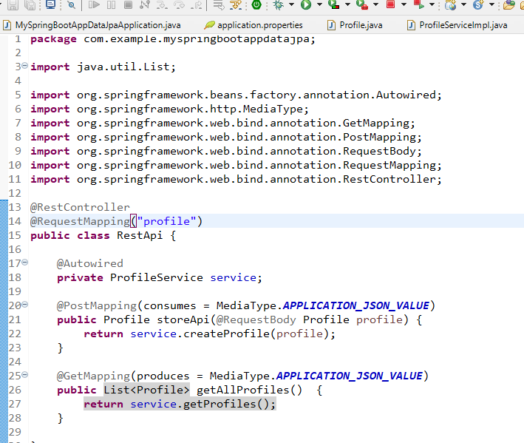

Spring Cloud main projects

Spring Cloud Config

Spring Cloud Netflix

Spring Cloud Security

Spring Cloud Configuration Server / Externalized Configuration:

Here the client & server can access the externalized configuration in a distributed system.

The externalized configuration location can be a filesystem / GIT

Features:

There are two things

1. Spring Cloud Server Features
   1. This takes care of locating the original location of the centralized repository/system
   2. Encrypt & Decrypt the sensitive information
2. Config Client Features
   1. This binds to the config server & spring environment will load the remote resource properties

You need to create 2 projects

1. Configuration Server
2. Configuration Client

Dependencies required for Configuration server:

Config-Server

Dependencies required for Configuration client:

Web

Config-Client

(Optionals: Jpa, Devtools, Actuator)

Config Server

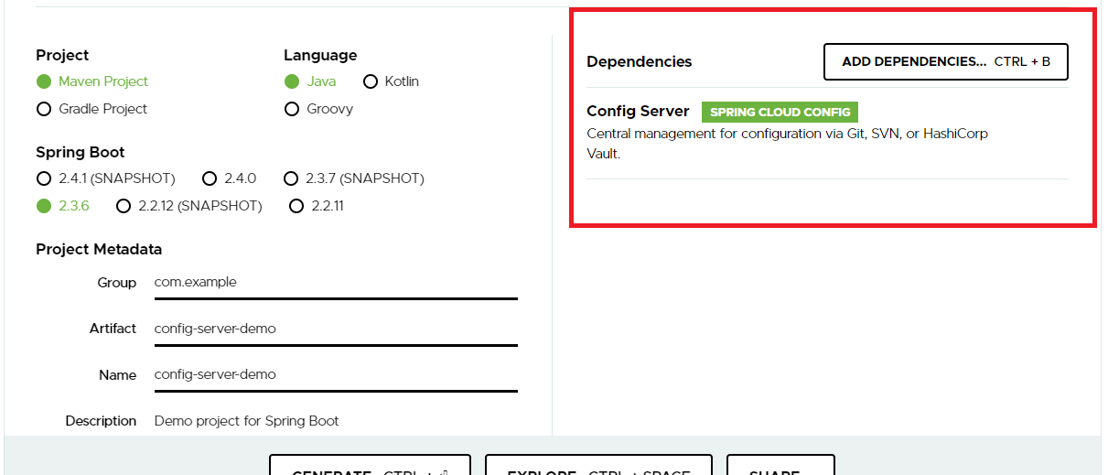

bootstrap.properties or bootstrap.yml: it is loaded before any property files, it is loaded at the time boostraping the application.

Create 2 yml files inside the configuration server project

bootstrap.yml

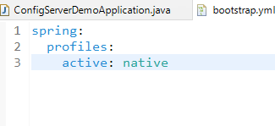

application.yml

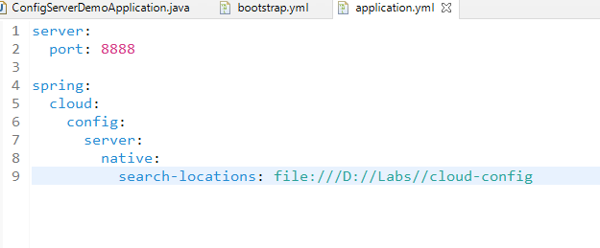

You can create one externalized configuration file in some directory.

remote-server.yml

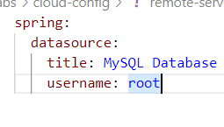

Now you can run the configuration server

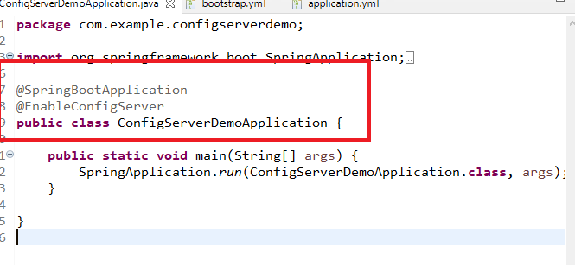

Client Program / Configuration Client

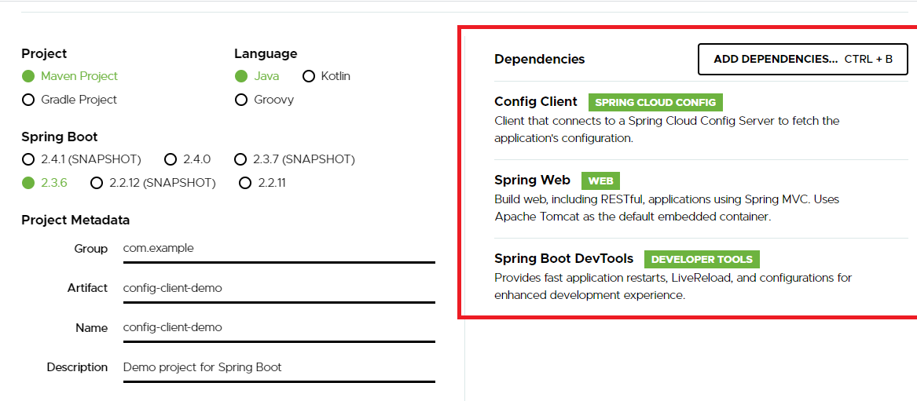

bootstrap.yml

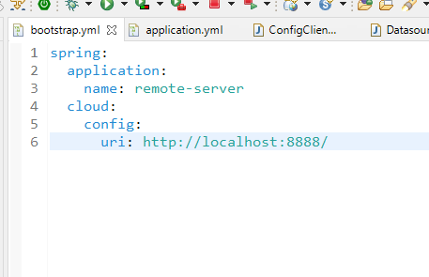

application.yml

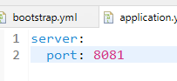

DatasourceConfig.java

Note: Here we are binding the external properties of configuration server to the DatasourceConfig variables

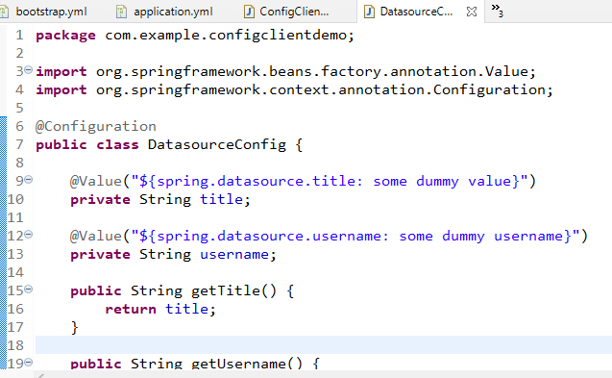

RestApi.java

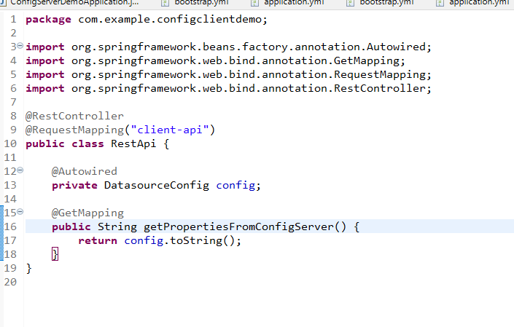

Now you can launch the client application

Output:

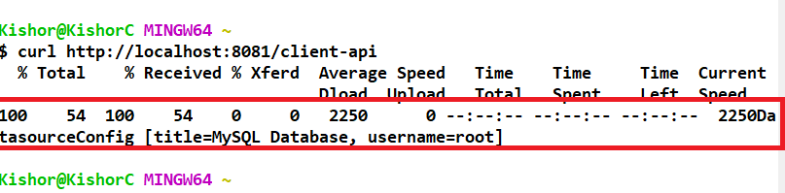

Note: If configuration server properties are modified it wouldn’t be affected to the client, because the client loads the configuration at the time of startup, hence you must use some kind of endpoints given by actuator where you can get the modified configurations or you can use pub/sub mechanism through the events automatically changes will be affected

How to use the datasource information from the configuration server

1. You must add spring-boot-starter-jpa & database drviver in the client pom.xml file
2. you must add datasource properties in the remote configuration server

remote-server.yml

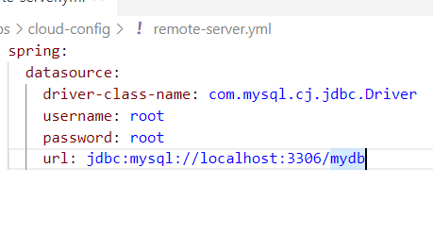

You can have Employee entity and JpaRepository interface type in the client application

Employee.java

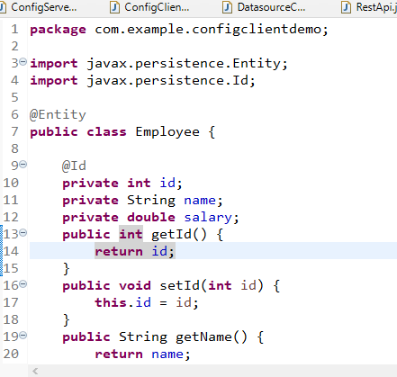

EmployeeRepository.java

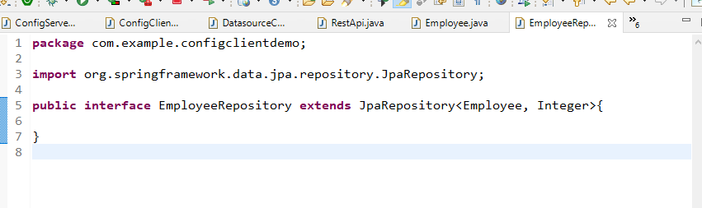

RestApi.java

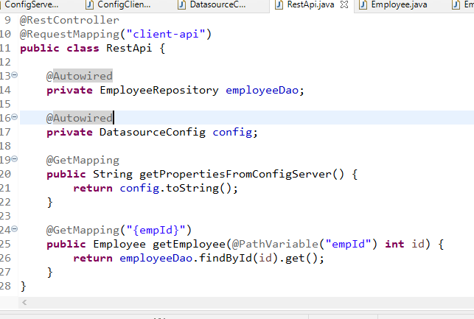

Output:

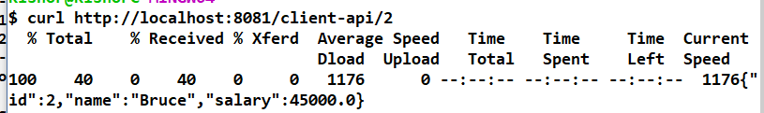

Todays Agenda

* Configuration server to pointing to GIT
* Search configurations in other locations
* Reloading the configurations without restarting the client application
* Encryption and Decryption of configurations (sensitive informations) - JCE
* Active Profiles: load the configurations based on the provide (developer, production, testing, default)
* Accessing the private repositories

Configurations using Git backend

You must use config.server.uri which comes as a part of Configuration Server library

Create remote-server.yml and push to git

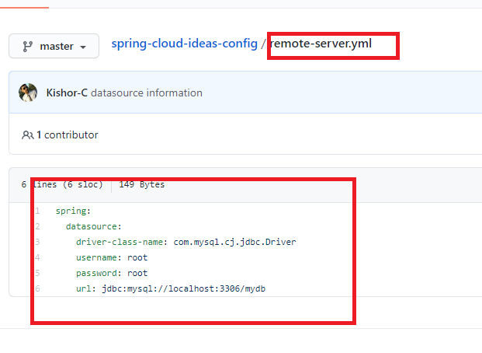

Configuration Server

No content in bootstrap.yml

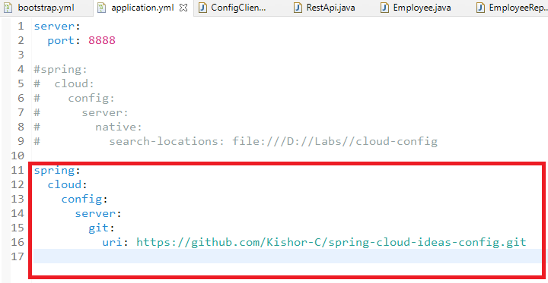

Configuration Client

bootstrap.yml

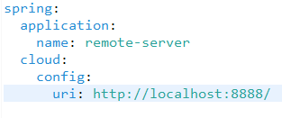

application.yml

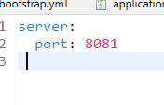

RestApi.java

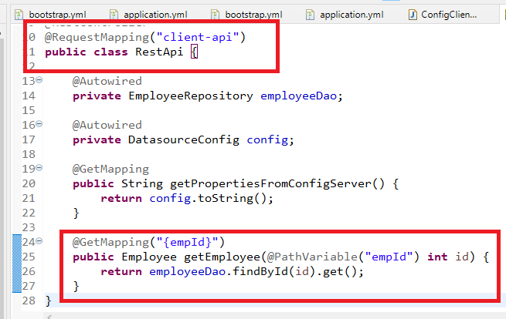

Output:



The configurations are not updated to the client so we can use actuator @RefreshScope.

You must add actuator library

<groupId>org.springframework.boot</groupId>

<artifactId>spring-boot-starter-actuator</artifactId>

</dependency>

Once you update the configuration file / configuration server, the client application can use the below end point

client-app-url/actuator/referesh

The Client application must also have exposed these above endpoints using below configuration in the application.yml

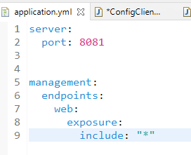

Enter refresh with POST method and empty JSON value as below:

curl -X POST -d {} -H “Content-Type: application/json” URL

Mention @RefreshScope on top the configuration class

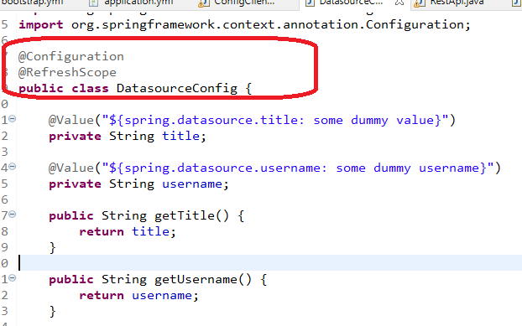

CURL command output after actuator/refresh

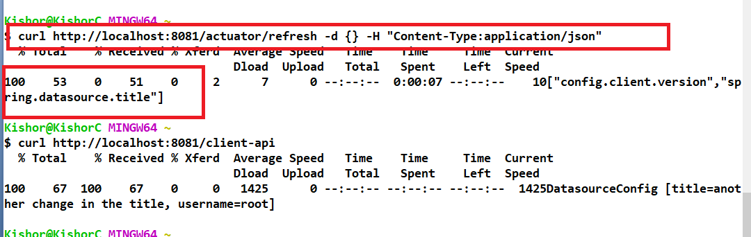

Encrypting and Decryption the Sensitive information

We must download JCE library from the Oracle web site & store inside jre/lib/security/ folder

Spring Cloud can perform encryption & decryption using some key, this key must be combination of special characters and better more than 12 characters.

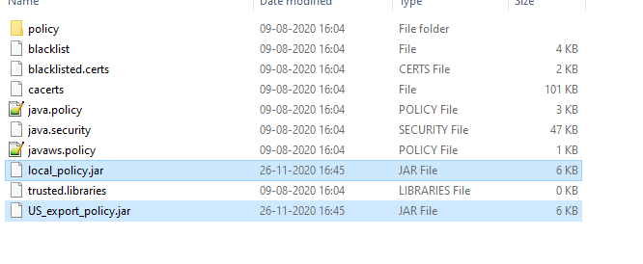local_policy.java & US_export_policy.jar are the two files which gives us the cryptographic algorithm

The only thing spring cloud must do is mention the encryption key and apply encrypt & decrypt.

Note: Configuration Server needs to specify the encrypt.key

bootstrap.yml

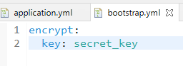

Perform encryption and add to the configuration file

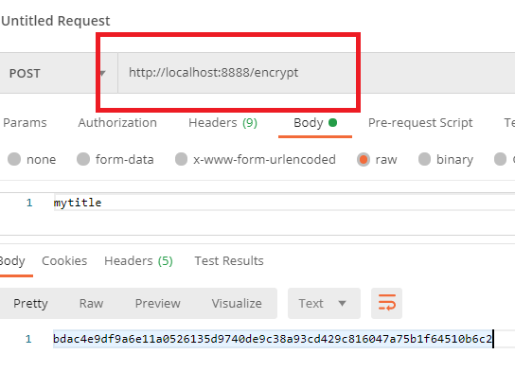

Add these code to the configuration file & push to the GIT

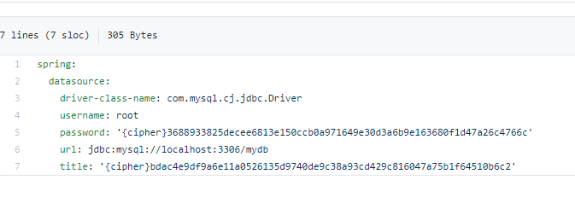

Now check the client endpoints to see the decrypted output

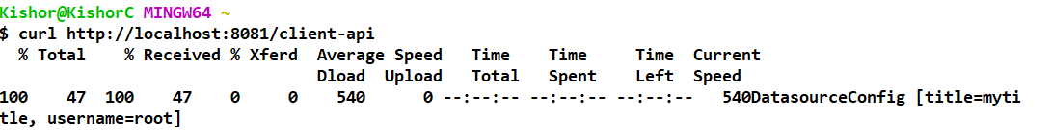

Private repository:

When you have private repository the configuration server must use username & password in the application.yml, else you will get below error where client application tries to fetch the configuration file

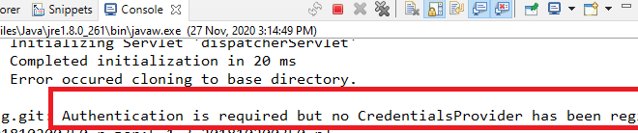

application.yml

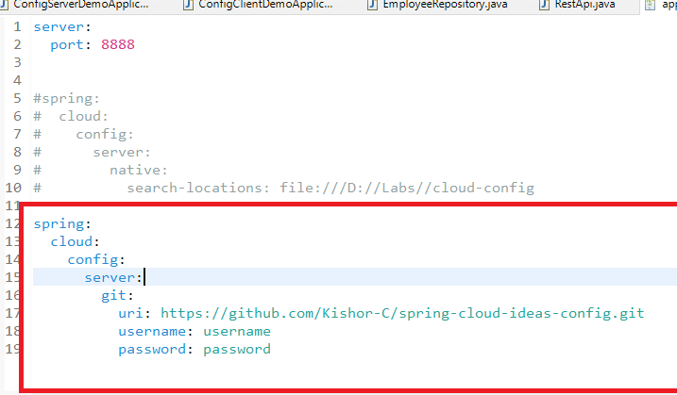

Loading the configurations based on the user profiles like

* development
* production
* qa

Here the configuration files will be stored in the naming pattern

configname.yml  
configname-development.yml  
configname-production.yml  
configname-qa.yml

You can mention these profile names using spring.active.profiles property.

You will have multiple configuration files

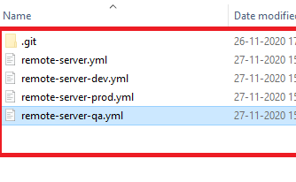

You can change any one property ex: title

remote-server-qa.yml  
 title = simple testing title

remote-server-prod.yml  
 title = simple production title

You can mention the profiles.active properties in the client configuration file or you can mention through terminal --spring.profiles.active

Note: bootstrap.yml of client application will have the profile configurations

bootstrap.yml (client-configuration -application)

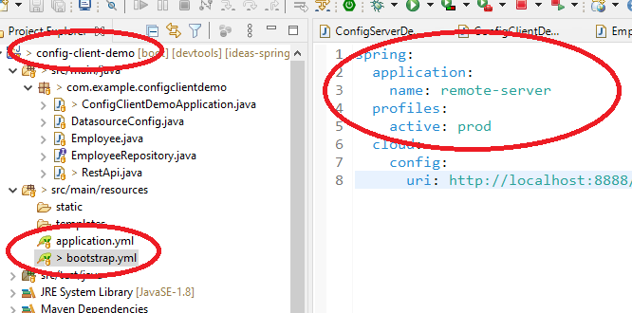

Output:

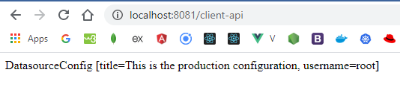

Note: You can give the profiles from the terminal without mentioning in the bootstrap.yml

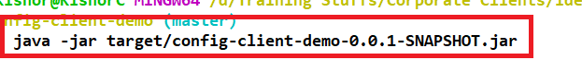

Loads the default configuration file remote-server.yml

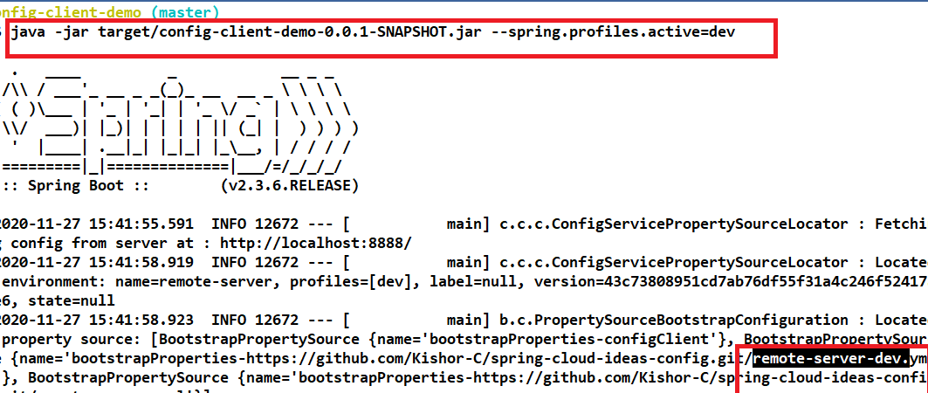

Output:

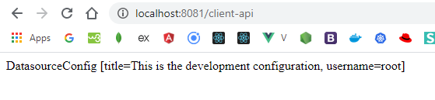

Suppose your configurations are present in different folder you can use search-locations property

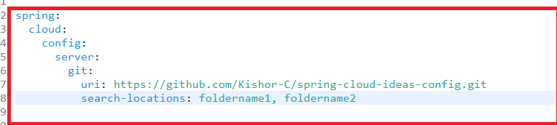

You can also load configurations from multiple repositories for that you can user

spring.cloud.config.server.git.uri = <<default-uri>>

spring.cloud.config.server.git.repos.uri = <<particular-repos-uri>>

Spring Microservices

Microservices are independent services which can be deployed on servers they are independent from other services of same project or different project.

Monolithic architecture

The entire application is built as a single deployable unit and they all share single code repository and it goes to the server.

Drawbacks:

1. If any service affects the other services and chances of entire application going down is high, that makes all the services to go down
2. If any changes happens in a module the entire application has to be rested and rebuilt
3. You can’t scale only few services you had to scale the entire application

Microservice architecture

Microservices are independent services which are deployed on servers independently

1. They are easily scalable
2. They don’t affect other services if any service goes down
3. Each service will have separate code base repository
4. Services don’t directly talk to other service databases
5. If any change happens in a microservice you dont’ have to test other services
6. Microservice communicate with other microservices using REST calls
7. It uses service discovery which is location transparent that makes microservice communications easier without changing the client code.
8. Various design patterns to simplify the work
   1. Service Discovery (Eureka Server)
   2. Load Balancing (Ribbon)
   3. Resilient pattern - Circuit Breaker (Hystrix/Resilience4j)
   4. Security pattern - OAuth2 and JWT
   5. Logging - Zipkin

Spring has made microservice development easier with the help Netflix implementation, through simple annotations you can get the job done.

Pre-requisites

* Spring Cloud
* Spring Boot

Service Discovery:

This is a design pattern where all the microservice can register them so that other microservices can locate, this helps to have a logical name that abstracts the physical location of the microservice.

* Multiple instances of same microservices will have same logical name
* Spring Netflix has given an implementation to the service discovery called EurekaServer, this can be enabled using @EnableEurekaServer
* This eureka server gives you the dashboard where you see all the registered services along with their instances
* Dependency we need is Eureka Server